**Fig.1 Experimental system**

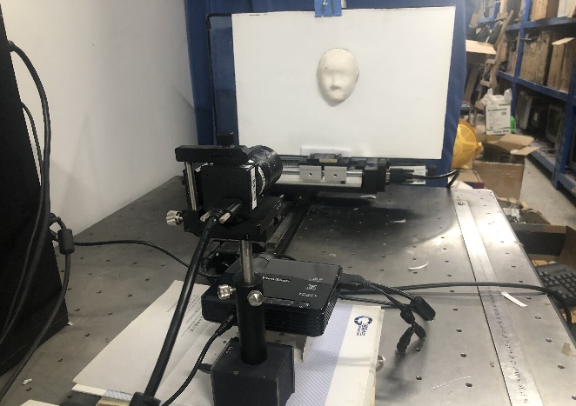

Reference plane

Measured object

Stepping motor

DFM 72AUCO2

PLED-W200

**Fig.2 Experimental data.** (a)Measured object, (b) grating pattern, (c)1st deform pattern, (d)2nd deform pattern, (e)1st R deform pattern, (f)2nd R deform pattern, (g) 1st B background image, (h) 2nd B background image

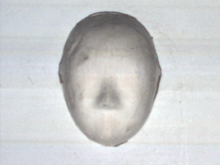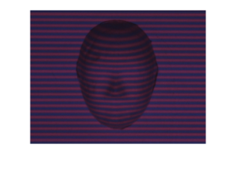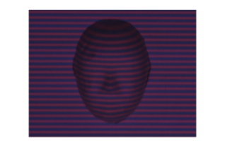

(a)

(b)

(c)

(d)

(e)

(f)

(g)

(h)

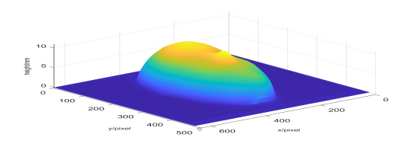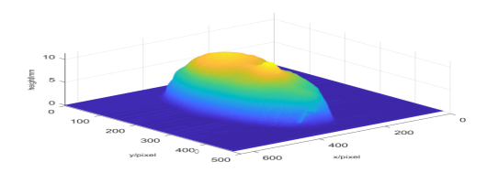

(a)

(b)

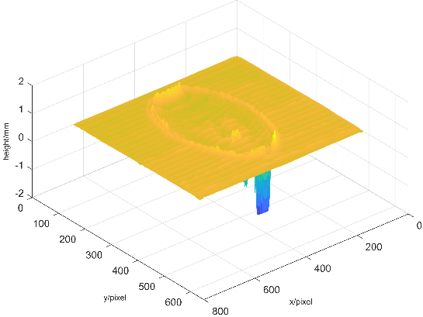

A

B

**Fig.3 Experimental results and height error distribution.** (a)Object reconstructed by ZHANG S′s algorithm, (b)Object reconstructed by proposed algorithm, (c)Sectional view of the 3D profile of the object, (d)Magnified view of the area A(e)Magnified view of area B, (f) Height error distribution of ZHANG S′s algorithm, (g) Height error distribution of proposed algorithm

(c)

(d)

(e)



(f)

(g)

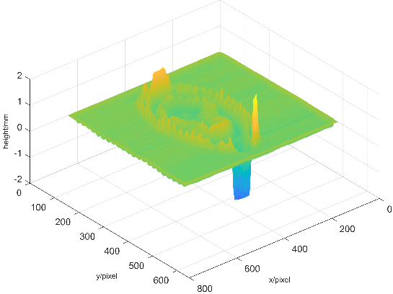

**Fig.4 Experimental results of real-time 3D measurement for moving double-layer rectangular model.** (a)-(c) 1st-3rd deform patterns , (d)-(f) 1st-3rd monochromatic deform pattens , (g)-(i)objects reconstructed of time 1 to 3

(a)

(b)

(c)

(d)

(e)

(f)

(g)

(h)

(i)

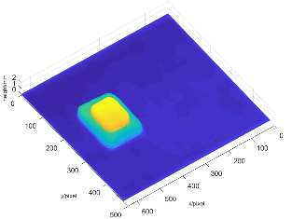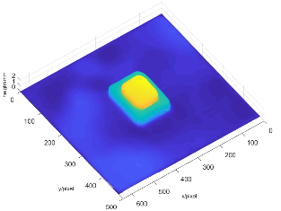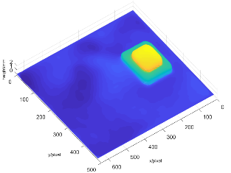

Figures that need to be linked



Visualization1 Visualization2

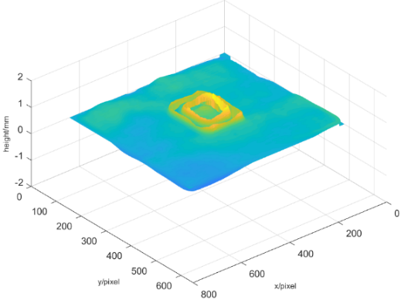

(a)

(b)

(c)

**Fig.5** **The** **235th row comparison results of the reconstructed object.** (a) Sectional view of the 3D profile of the object, (b) Magnified view of the A area, (c) Magnified view of the B area(d) Magnified view of the C area, (e) Height error distribution of ZHANG S′s algorithm, (f) Height error distribution of proposed algorithm



B

A

C

(d)

(e)

(f)

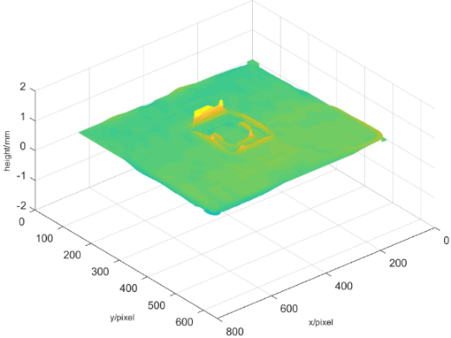

Table.1 The height root mean square error at different speeds

method

Speed(mm/s)

|  |  |  |  |
| --- | --- | --- | --- |
|  | 24mm/s | 30mm/s | 36mm/s |
| ZHANG S | 0.0817 | 0.1055 | 0.1443 |
| Proposed method | 0.0410 | 0.0517 | 0.0706 |

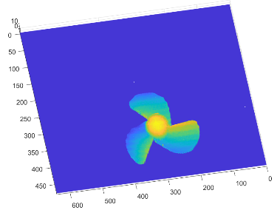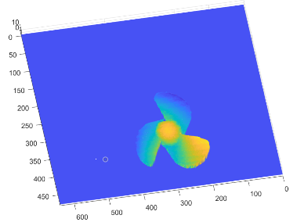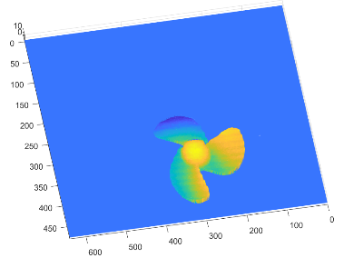

**Fig.6 Experimental results of real-time 3D measurement for moving sector model.** (a)-(c) 1st-3rd deform patterns, (d)-(f) 1st-3rd monochromatic deform pattens, (g)-(i)objects reconstructed of time 1 to 3

(a)

(b)

(c)

(d)

(e)

(f)

(g)

(h)

(i)

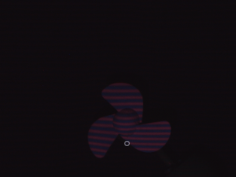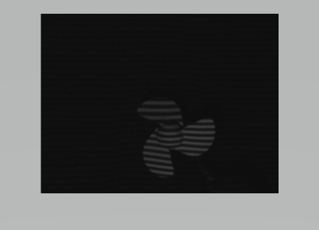

Figures that need to be linked



Visualization3 Visualization 4